**MUHAMMAD-HAMMAD**

**LAB-8**

**QUERY-1**

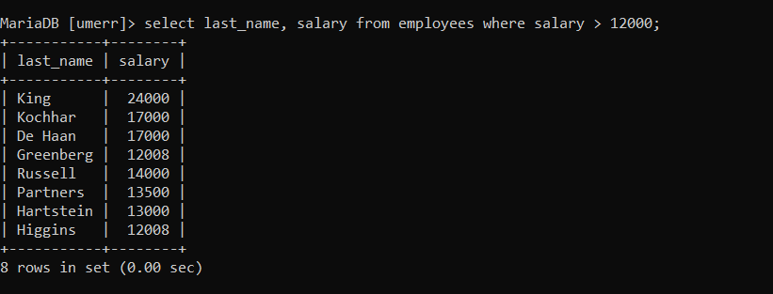

**QUERY-2**

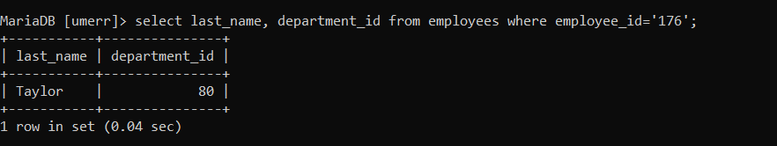

**QUERY-3**

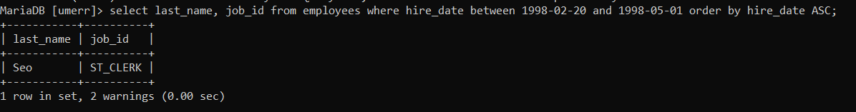

**QUERY-4**

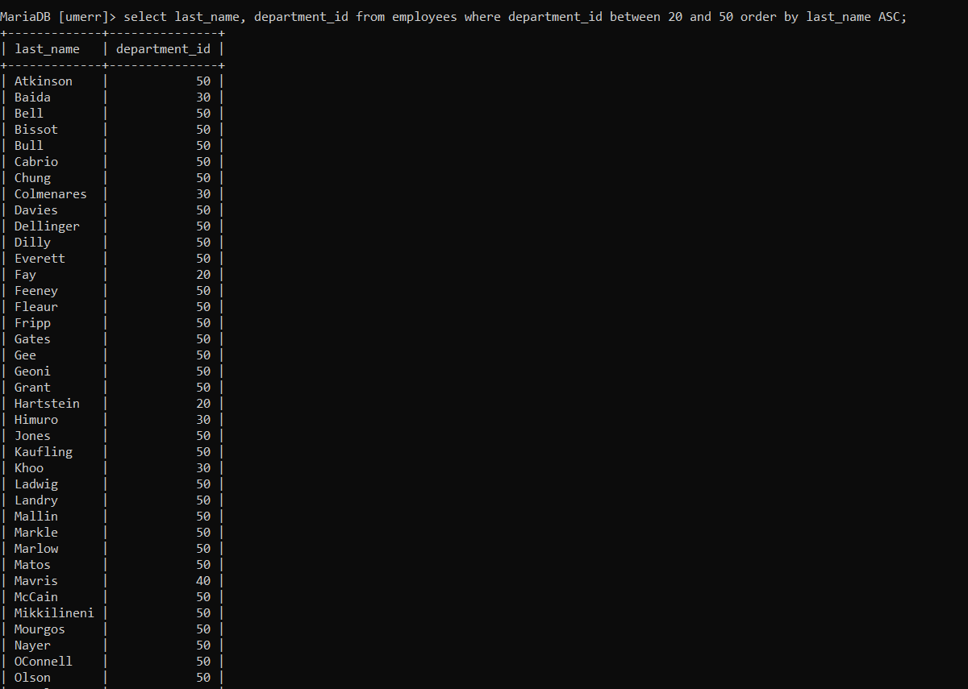

**QUERY-5**

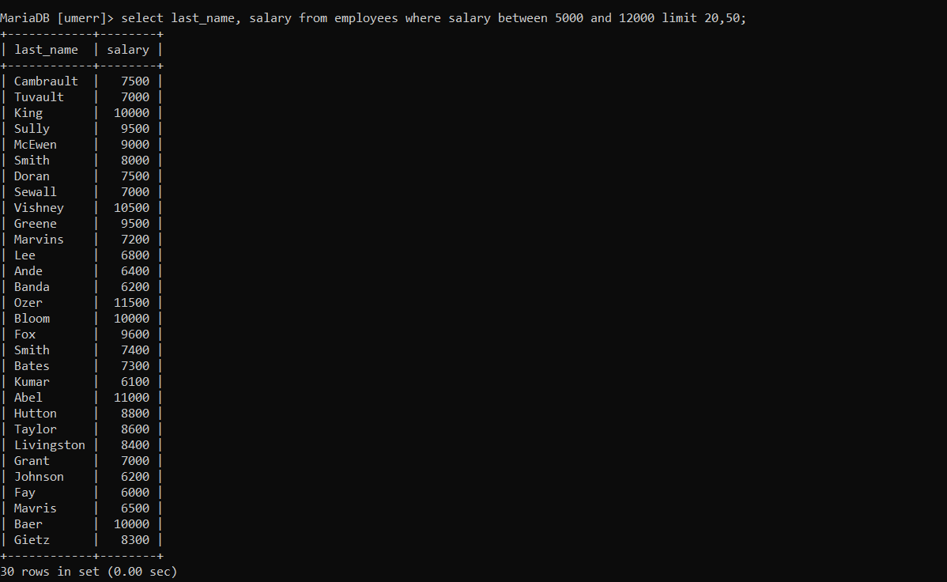

**QUERY-6**

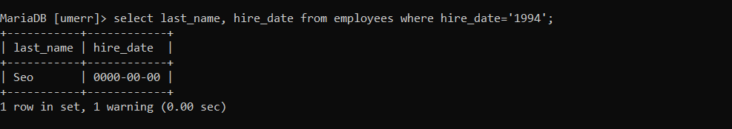

**QUERY-7**

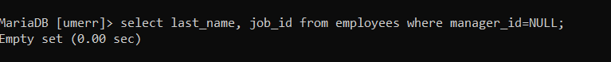

## QUERY-8

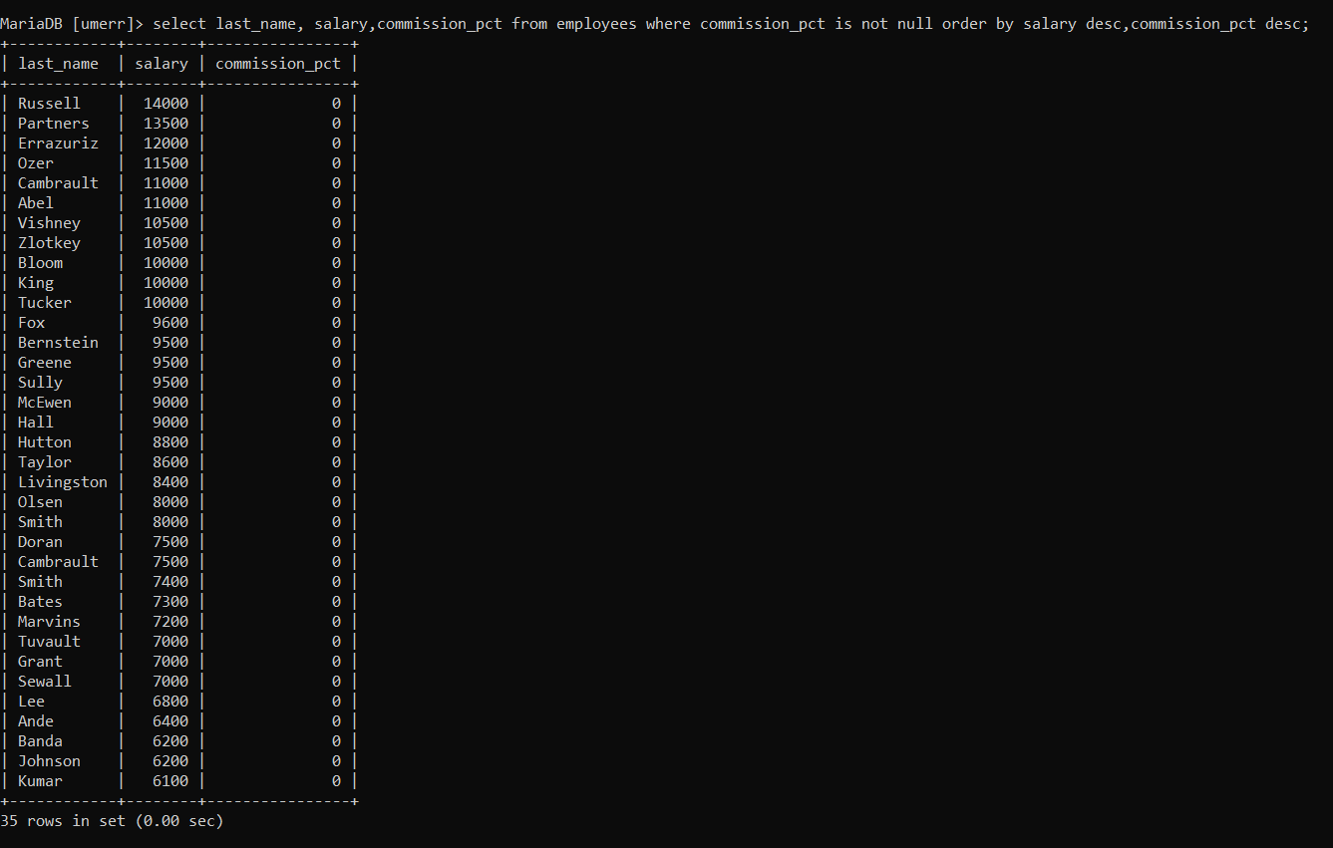

**QUERY-9**

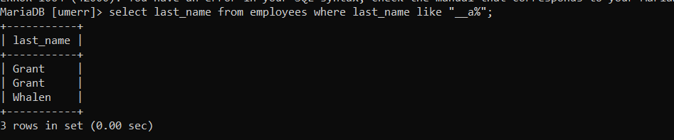

## QUERY-10

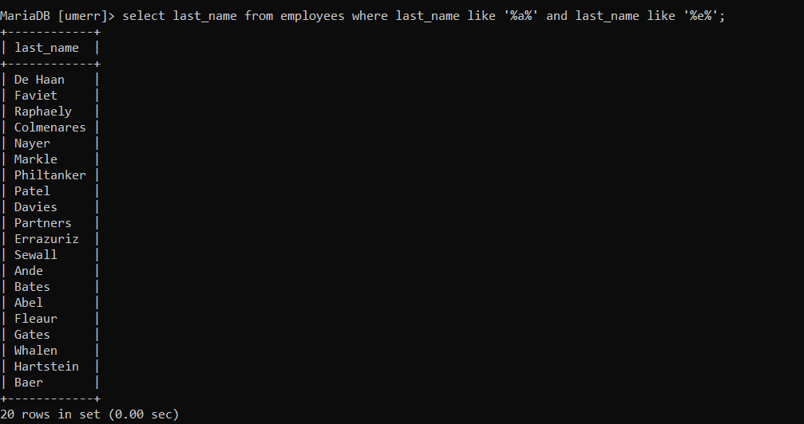

**QUERY-11**

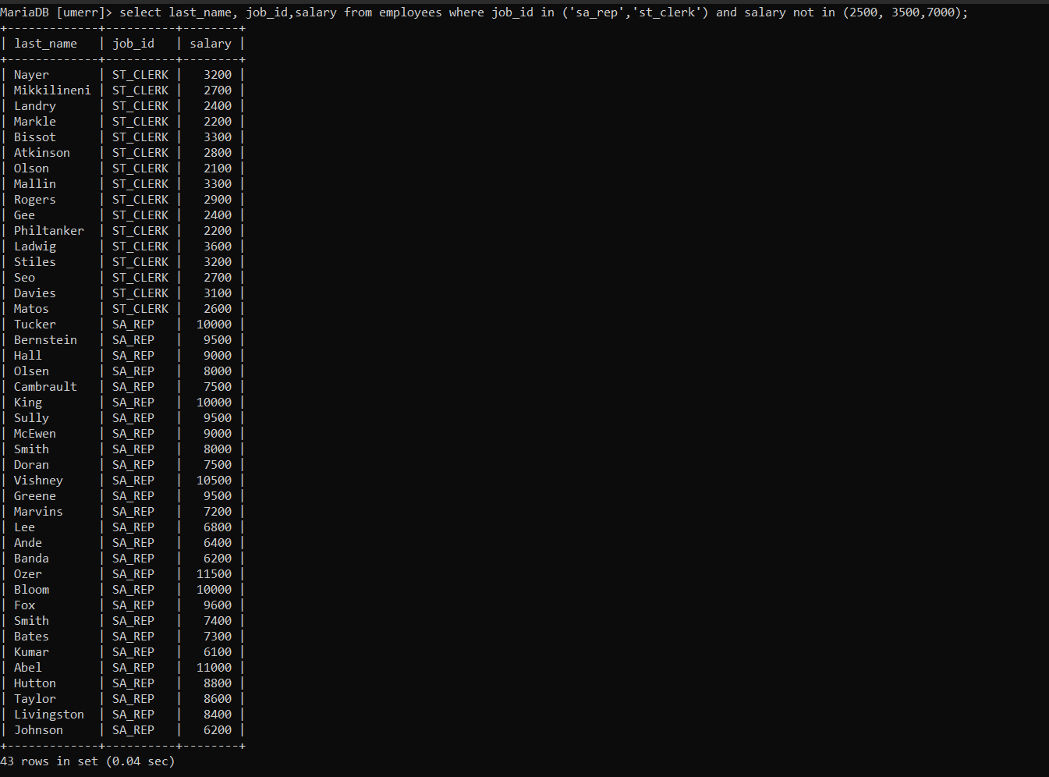

**QUERY-12**



**QUERY EXPLANATION**

**QUERY1**:Createaquerytodisplaythelastnameandsalaryofemployeesearningmorethan12,000 Rupees

**QUERY2:** Createaquerytodisplaytheemployeelastnameanddepartmentnumberforemployeenumber 176

**QUERY3:** . Displaytheemployeelastname,jobID,andstartdateofemployeeshiredbetweenFebruary20, 1998, and May 1, 1998. Order the query in ascending order by startdate.

**QUERY4:** Displaythelastnameanddepartmentnumberofallemployeesindepartments20and50in alphabetical order byname.

**QUERY5:** Show the list of last name and salary of employees who earn between 5,000 and 12,000Rupees, and are in department 20 or 50. Label the columns Employeeand Monthly Salary, respectively

**QUERY6:** Display the last name and hire date of every employee who was hired in1994.

**QUERY7** Display the last name and job title of all employees who do not have amanager.

**QUERY8:** Displaythelastname,salary,andcommissionforallemployeeswhoearncommissions.Sort data in descending order of salary andcommissions.

**QUERY9:**

Display the lastnames of all employees where the third letter of the name is ana

**QUERY10:** Displaythelastnameofallemployeeswhohaveanaandaneintheirlastname.

**QUERY11:** Displaythelastname,job,andsalaryforallemployeeswhosejobissalesrepresentativeorstock clerk and whose salary is not equal to 2,500, 3,500, or7,000 Rupees

**QUERY12:** Displaythelastname,salary,andcommissionforallemployeeswhose commission amount is 20%

.

**Unseen Task 2**

1. **QUERY-1**

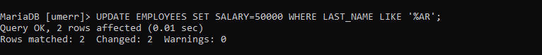

1. **QUERY-2**

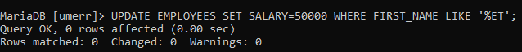

1. **QUERY-3**

